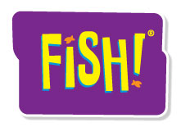
Customizable Half-Day FISH! Grid Outline
Build your own agenda!
Some facilitators like their agenda laid out in grid format. They like to see at a glance what’s coming up, how long it will take and what props they need. This grid will help you prepare and create comfort for your engaging event!

Timing | Content | Props | Others
 | Introductions/Building Community
 | FISH! Film, Setup and Review
 | Be There
 | Play
 | Make Their Day
 | Choose Your Attitude
 | Action Planning
 | Commitment Ceremony
©MMVIII ChartHouse Learning. All Rights Reserved.

