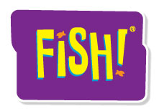
Customizable Half-Day FISH! Event Outline

I. Introduction/Building Community
- Opening/Welcome
- Introduce Self
- Participant Introduction Activity
- Gather Top Issues/Concerns

II. FISH! Film, Setup and Review
- Best Job/Worst Job Activity
- Introduction to the FISH! Film
- Film
- Debrief Practices
- Practices vs. Principles
- Group Discussion on Practices

III. Be There
- Definition
- Activity
- Summary
- Action Ideas

IV. Play
- Definition
- Activity
- Summary
- Action Ideas

V. Make Their Day
- Definition
- Activity
- Summary
- Action Ideas

VI. Choose Your Attitude
- Definition
- Activity
- Summary
- Action Ideas

VII. Action Planning
- Activity—Four Corners
- Application/Action Planning
- Summary

VIII. Making the Commitment
- Summary of Practices
- The Power of Commitment
- Commitment Ceremony
- Thanks and Next Steps (Evaluations)
©MMVIII ChartHouse Learning. All Rights Reserved.

