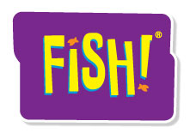
Keep-It-Simple Event Preparation Worksheet

When preparing any group event—a meeting, a camping trip or a FISH! event—keep your planning simple. There will be numerous details to take care of or to delegate, but your focus should be clear: What is the goal? And what impact do I want this session to have?

What do you want participants to know and have experienced when they leave your event? State your goal(s) as clearly and concisely as you can.

How would you like participants to feel when they leave? (e.g., inspired, contemplative, etc.)

To keep focused on the goal, start with essential logistics. Nail down as many of the following as you can early in the process:
Date: | Start Time: | Stop Time:
Number of Participants: | Number of Locations: | Break Time:
Food/Beverages: | Budget: | Special Room Considerations:
Materials/Equipment:
Laptop Computer
LCD Projector
Speakers
Video Player
Projector Screen
Wireless Microphone
Music Player
A/V Cables
Extension Cord
Multi-Plug Strip

Who can help you with the event?
Name: | Responsibilities: | Due Date:

Notes:

